Contact details

Title Dr

Family name MANTILLA

First name ANECITO JR

Mailing address
PO BOX 736
Suburb/

Town KOTARA Post code 2289

Phone 0439383622

Fax 02-82143471

Email johnmmd@mantillaph.net

If you operate with more than one Australian Business Number
(ABN), photocopy this form and lodge a separate form for each ABN.

Notification of Australian Business Number (ABN)

Please tick which group you come under:
- A Non Government Organisation - or
- A Visiting Medical Officer - X or
- Any other (please provide details) -

ABN (11 digits) | 4 | 3 | 1 | 5 | 2 | 0 | 8 | 3 | 9 | 9 | 7

Branch registration number if applicable (3 digits)

Business/Trading Name under which the ABN is registered
MANTILLA MEDICAL PTY LTD

Effective date for ABN (as advised by ATO)
1 | 3 | / | 0 | 7 | / | 2 | 0 | 1 | 1

Do you want this ABN to be used for ALL payments effected by Hunter New England Local Health Network

Yes X No If no, please provide an attachment
explaining the arrangement you require.

Please return your completed form to:

Medical Workforce Support
PO Box 21
Waratah NSW 2298

Tel: 02 4985 3172 * Fax: 02 4985 3273

Recipient-Created Tax Invoice (RCTI) Agreement
What is the RCTI Agreement?
For payments over $50, there is a requirement to issue a Tax Invoice (if GST applies to the payment.) Hunter New England Local Health Network recognises that for many payments, as the payer, it actually calculates the value of supply. Therefore, the legislation allows Hunter New England Local Health Network to do all the necessary paperwork, making it easier for you. To do this, Hunter New England Local Health Network needs an RCTI Agreement signed by the appropriate representative of your enterprise or employer. Hunter New England Local Health Network recommends that an agreement be completed if payments are being received (or could be received in the future) where GST applies.

Please Note
You must be registered for the GST to enter into an RCTI Agreement. If you do not sign the RCTI Agreement below, Hunter New England Local Health Network will assume you are not required to register for the GST, or you are not expecting to receive any taxable payment from Hunter New England Local Health Network.

Please read the condition of the agreement below.
Conditions of the Agreement:
- Hunter New England Local Health Network will issue RCTIs in respect of all taxable supplies made by you to Hunter New England Local Health Network on its own behalf or as an agent, in return for Hunter New England Local Health Network payments.
- You must not issue any Tax Invoices in respect of those supplies.
- You are registered for GST purposes at the time of signing this agreement and have notified Hunter New England Local Health Network of your ABN in the space provided on this form.
- You must notify Hunter New England Local Health Network on its own behalf or as an agent, immediately should you cease to be registered for GST purposes or you become aware of any reason why your registration may be cancelled.
- The ABN for Hunter New England Local Health Network is 63598010203 and Hunter New England Local Health Network is registered for GST from 5 January 2011.
- Hunter New England Local Health Network must notify you immediately they cease to be registered for GST purposes or become aware of any reason why their registration may be canceled.
- By signing below, you warrant that you are properly authorised to agree to the terms of this agreement which, when received by Hunter New England Local Health Network on its own behalf or as an agent, will become legally binding.

A person properly authorised to agree to the terms of this RCTI agreement (company secretary or CEO) must sign here.

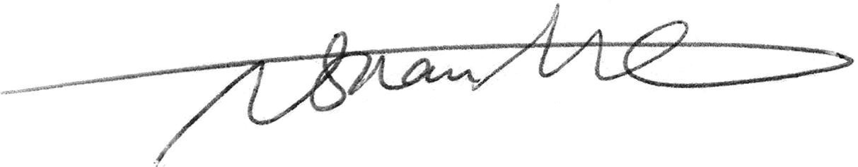
Signature for the RCTI Agreement
Print name:
Dr Anecito Jr MANTILLA
Date:
0 | 4 | / | 0 | 9 | / | 2 | 0 | 1 | 2

For Hunter New England Local Health Network
Print name:
Date:
 |  | / |  |  | /

