Charina Mantilla
17 Valley View Street Glendale NSW 2194 Phone: 02 4023 5598

5th September 2014

Asteron Life
GPO BOX 68
Sydney NSW 2001
Ph: 1800 221 727

ATT: Customer Service

Re: Automatic Increase Cancellation Request
Life Insured: Mrs Charina Mantilla
Policy Number: 81467507- Life & TPD Super
Policy Number: 81467508- Trauma & TPD non super

I the above mentioned policy owner wish to cancel my automatic increase offer benefit with my 2 Asteron Life policies and wish to maintain the same sum insured benefits from policy inception.

Regards

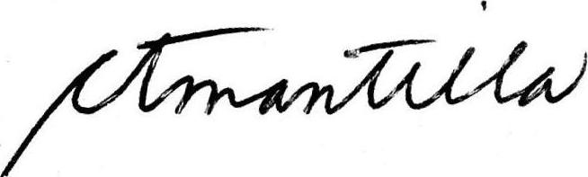
_______________
Mrs Charina Mantilla

